
DELHI PUBLIC SCHOOL, HAPUR
Session 2025-26
DPS CODERZ LEAGUE COMPUTER COMPETITION
Class – V
RESULT DECLARATION

Students’ Name | Class & Section | Position | Winners
Shivank Singh | V C | I | 
Shivansh Tyagi | V C | II | 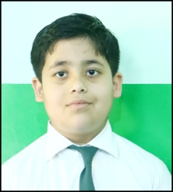
Aadhya Agarwal | V A | III | 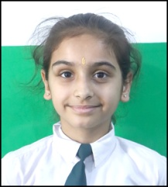
Arhaan Ahmed | V A | Consolation | 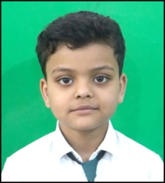
Arayana Jayant | V A | Consolation | 